Home learning Summer Term - Year 3 wc 6th July 2020

Writing
Below are five writing activities for you to do every day. The videos on google
classroom will link to these activities.
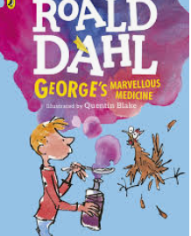
This week the writing will be based on the book: George’s Marvellous Medicine.
We will be writing character descriptions this week!

https://www.slideshare.net/SharenGanesh/georges-marvellous-medicine
The story is here if you would like to read it.

Monday 6th July
LO: To describe a character.

What do you use to describe a character?
How would you describe yourself?
You would use adjectives!

Look at this character below. Can you describe what he looks like? How might he act?
What does he look like?
Standing strong, he…
He looks…
The noise he makes is…
His colours are…
How does he act?
He enjoys…
He likes to…
Walking down the road, he…

Tuesday 7th July
LO: To use adjectives and adverbs.

Activity 1
Write a definition for an adjective and an adverb.

An adjective is…
An adverb is…

Activity 2
Sort the list of words below into 2: adjectives and adverbs.

adventurous | adorable | quickly | brave
angrily | bright | joyful | intelligently
weirdly | vividly | kindly | lazy
youthfully | amusingly | keen | jubilant

Activity 3
Can you write 5 sentences that include 1 adjective and 1 adverb in it?

The intelligently adorable boy ran across the school playground to his mum standing on the other side.

Make sure they are extended sentences.

Activity 4
Can you write a short paragraph that includes more adverbs and adjectives? You can write about yourself.

Wednesday 8th July
LO: To plan a character description.

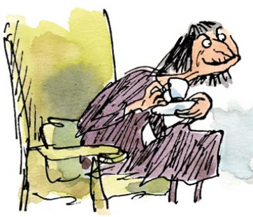
Tomorrow you are going to write a character description on Grandma from George’s Marvellous Medicine.
Today you are planning the character description. Use the planning sheet below.

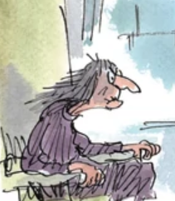  Grandma | Her personality:
What does she look like? | 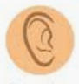  What does she sound like?
What does she smell like? | What does she like to do?

Thursday 9th July
LO: To write a detailed character description.

Using your planning sheet, now you can write a character description on Grandma.
Here is a word bank with sentence stems, adjectives and adverbs:

Sentence stems:
Sitting in her chair, she…
Screeching at the top of her voice, she would say…
She looked like…
Pointing her finger, she would…
Her face looked…

Adjectives:  crooked  bad  evil  atrocious  ugly  disgusting  horrid  wicked | Adverbs:  slowly  carefully  menacingly  quickly  loudly  silently  rudely  bitterly

George’s Grandma was an interesting character. She was evil and bitter mixed into one and stuffed into an old wrinkly body. She looked like she had been around for thousands of years as her wrinkles were ever so wrinkly, her grey hair was ever so grey and her teeth were ever so fallen out. Her body was hunched over and weak, she had to hold herself up with a walking stick which she also enjoyed pointing at people.
Sitting in her chair, she would screech loudly at anyone and everyone that would walk by. Ordering this and that and everything. Pointing her long bony finger, she would look closely at her family, making sure they had their full attention on her. She was atrocious and she loved it.

Friday 10th July
LO: To complete the story.

Well done on the amazing work you have completed this week. Now you have a chance to write independently.
From where we left off, can you now write the rest of the story. Because you know the story already, you can either write the actual ending or you can make it up yourself!

Finish the rest of the story after this sentence:
George watched Grandma as he slowly lifted the spoon to her wrinkly, old mouth. In slow motion, she swallowed and she looked at George in a curious way. She know something strange was happening. Something peculiar…

