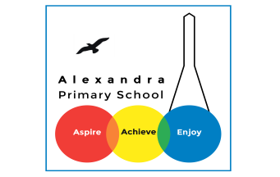
Year 3 Reading
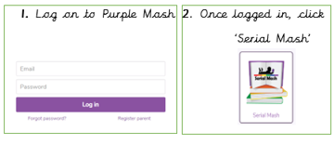
Log in to your Purple Mash account. Visit Serial Mash, Emeralds, and find the book ‘Treasure’s Island’.

Monday 29th June: Read Chapter 1 and Chapter 2. The PDF text for Chapter 1 is here and the PDF for Chapter 2 is here. Then complete the quiz for Chapter 1 and Chapter 2.

Challenge Question
(Answer these in your exercise books- write the date and the title of the text).
Jen is worried about her granny and is going to write a letter to Mrs Lovewell. Imagine you are Jen. Can you write a letter to Mrs Lovewell for her? Remember to ask lots of questions about the parrot, Treasure.

Tuesday 30th June: Read Chapter 3. The PDF for Chapter 3 is here. Complete the quiz for Chapter 3.
Challenge question
?
In this chapter, Granny and the parrot, Treasure, have gone missing. Can you make a prediction about where they have gone? Remember to use your prediction stems.

Wednesday 31st June: Read Chapter 4. The PDF is here. Complete the Chapter 4 quiz.
Challenge question
At the end of this chapter, Granny and Treasure have taken the boat without permission. Do you think it is okay that they did this? Please explain your answer.

Thursday 1st July: Read Chapter 5. The PDF for Chapter 5 is here. Complete the Chapter 5 quiz.
Challenge question
What treasure do you think Granny and Treasure are looking for? Can you describe where you think it might be, what it might be in and what the treasure might be.

Friday 2nd July: Read Chapter 6. The PDF for Chapter 6 is here. Complete the Chapter 6 quiz.

Challenge question
You have now finished the book.
Can you write a review of it?

If this story is too hard to follow, some of you have also been assigned an alternative reading book ‘’Ned and the Jungle Animals’.
You should do this instead.

Daily Activity
You should be reading for at least 30 minutes daily.
If you cannot access Purple Mash, choose a book of your own and use your Destination Reader stems to record your thoughts in your Exercise books. This should be done each day.

Date: 29.06.2020
Name of Book:
Prediction: I wonder if…
Inference: The word __ tells me…
Summary: The key idea is…

Daily Activity
You should be reading for at least 30 minutes daily.
If you cannot access Purple Mash, choose a book of your own and use your Destination Reader stems to record your thoughts in your Exercise books. This should be done each day.

Date: 20.04.2020
Name of Book:
Prediction: I wonder if…
Inference: The word __ tells me…
Summary: The key idea is…

Fun Activity of the Week
Comic strip
Turn a story/book into a comic strip
You could do this either on a book you have read or are reading OR make up your own.

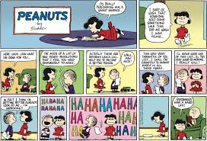

Story Time Ideas
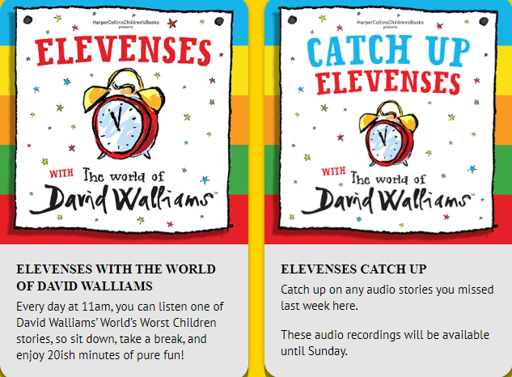
There are lots of different ways you can access books and stories on-line. Here are some.
https://www.worldofdavidwalliams.com/elevenses/
Story Time Ideas

Audiobooks and eBooks are available to borrow for free from Hackney library, using these apps; Overdrive and Borrowbox. You will need to download these apps to a tablet, phone or computer. To use these apps, you will need a library card number from any London library. If you are not a member of the library, you can join for free here: https://hackney.gov.uk/libraries#join. You won’t need to go into the library to provide proof of address as you normally would, but can do everything online
There are also a lot of websites where you can watch authors read their books for free:
- Storytime Online has hundreds of videos: Click here to view
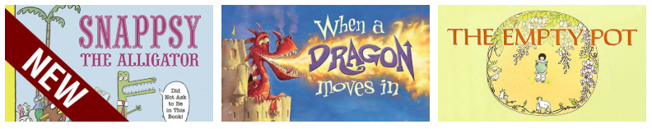

- You can also find stories at this website: https://www.getepic.com

Select, “Have an account? Log in” then click “Students and Educators”. Log in with the class code: mxy1661

